The Final Flight of UA93 on 9/11: a Preliminary Comparison of Competing Theories
Frank Legge, (B.Sc., Ph.D., Chem.)
Jan 2015
The word “Preliminary” is placed in the title in the expectation that further information and improvements in the accuracy of calculations will be incorporated in the future.
Under consideration here is the last flight of United Airlines 93 (UA93), a Boeing 757. This was one of the four aircraft which were involved in the events of 9/11. These aircraft were apparently hijacked and all flights terminated in destruction of the aircraft. The nature of the destruction has been disputed in the cases of AA77 and UA93. The case of AA77, which apparently hit the Pentagon, has now been well documented and thought by many to have been brought to a satisfactory conclusion. Flight UA93 remains a mystery. This flight terminated near Shanksville and several theories have emerged. The theories to be considered here include the following:
- The official theory: the hijackers deliberately crashed the aircraft at 10:03:11, after passengers appeared likely to gain control.
- A theory based on seismic data: the plane crashed at about 10:06.
- A theory which attempts to accommodate the later time into the official theory by accounting for the seismic signal as due to a sonic boom.
- A theory that the plane was shot down, supported by claims that debris was widely scattered.
In an initial scan of these theories the following may be noted:
There is a discrepancy of about 3 seconds between the official crash time and the time of the last report in the FDR. John Farmer, using radar data, has determined that the clock running the FDR was about 3 seconds slow, thus no dispute with the official narrative arises here. There seems to be no reason to doubt the time of the final recording except for the seismic data. The seismic signal strength, however, has been described as being similar to the background noise level and therefore does not provide strong evidence. Witness testimony generally corresponds with the official description but is, to some extent, confusing, as will be discussed. Despite frequent claims to the contrary, there is significant debris at the Shanksville site.
There has been a lack of investigation of a jet aircraft flying in the vicinity of the crash site, which may have had the potential to create a sonic boom.
FDR acceleration data
It is surprising that the Flight Data Recorder (FDR) from UA93 did not record a sudden longitudinal deceleration in the last frame. This deceleration, the maximum value possible for the system, was recorded for the plane which hit the Pentagon, AA77. Also the Cockpit Voice Recorder (CVR) did not record the loud sound that would be expected as the nose of the plane hit the ground. These imply a failure within the plane before impact, supporting but not proving the theory that the plane was shot down.
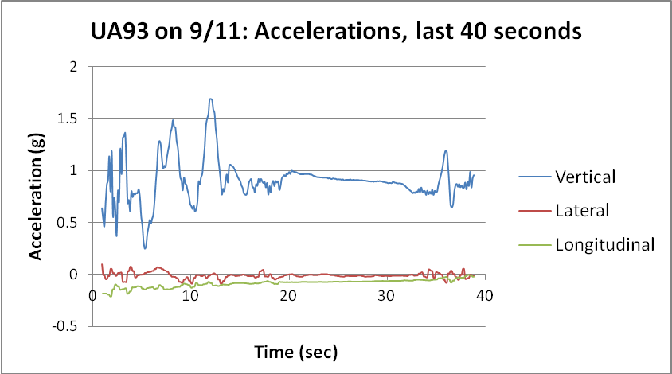
Fig. 1 FDR acceleration data from UA93.
FDR Engine data
Something surprising happened just prior to the termination of the flight of UA93.
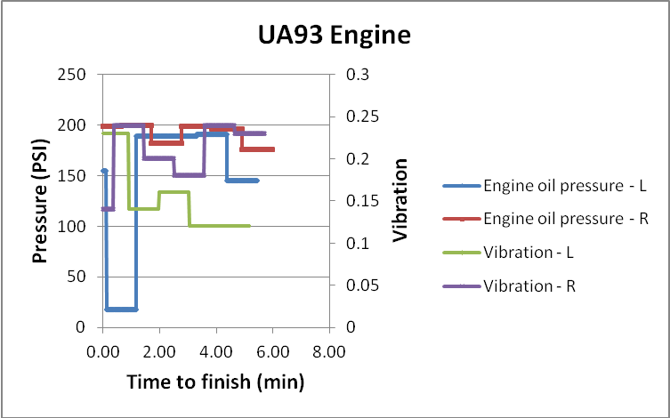
Fig. 2 FDR oil pressure and vibration.
The second last reading of the oil pressure of the left engine showed that the pressure dropped to an extremely low level (Fig. 2). Was this real or did it indicate a breakdown of the signalling system? A temporary glitch is suggested by the fact that the pressure recovered at the next reading. At first glance it seems that the low oil pressure reading might be real as the vibration increased substantially at the same time. This is not convincing, however, as it is clear that the vibration readings can vary widely: for example see the vibration of the right engine. This data is not very helpful regarding the exact time of the incidents as these recordings are only made about once per minute. The theory has arisen that this drop in oil pressure indicates that the engine has been struck by a missile. It is an intriguing observation but provides no proof.
FDR Altitude Data
A range of data from the FDR file is displayed in the graph below (Fig. 3). Pitch is shown negatively to avoid expanding the graph below the zero line. The radio height has been adjusted by adding 7 feet so that contact of the fuselage horizontally with the ground would give a reading of zero. The radio altitude is derived by adding the radio height to the ground elevation. The equipment recording the radio height started to operate in this plane when it descended below 5400 feet above the terrain. It operated normally for 7 seconds then failed when the plane rolled excessively. In the graph the pressure altitude has been adjusted to align it with the radio altitude for these few seconds. During this period the height averages about 5000 feet. The radio height instrument is accurate to about a foot when close to the ground but can have an error which increases with height. The maximum error found in the literature is 5% which, in this case, comes to 250 feet.

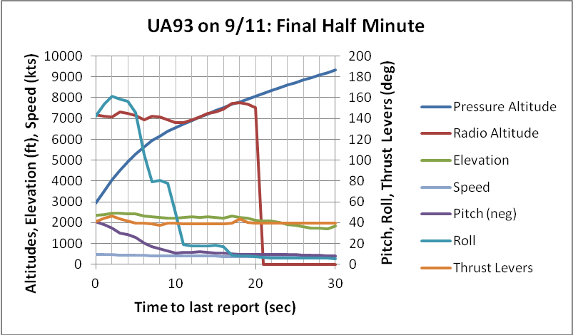
Fig. 2 FDR data from UA93, various parameters.
At the time of the last valid FDR reading the pressure altitude, adjusted as above, is 2960 feet. The elevation is 2361.4 feet, thus the calculated height above ground at that moment is 598.6 feet. If the system had been just about to record another set of data when it was destroyed, the final altitude would have been approaching ground level, as can be seen in the following graph (Fig.4). How far the plane progressed along this path can be evaluated by reference to the “words” in the FDR data. There are 16 words from the last pressure altitude recording, which occurred in the second last subframe, to the last valid recording in the final, incomplete subframe. There are 64 words to a second, so the system continued to operate for a further 0.25 seconds after the last pressure altitude was recorded. The recorded pitch of the plane was steepening as the plane descended, finally reaching -41.1 degrees. This figure may be unreliable as the plane was almost on its back at the time. An alternative value can be derived from the last air speed, 487.5 kts, and ground speed, 386 kts. These give a pitch value of -37.6 degrees, 52.4 degrees from the vertical. This would produce a further descent of 125.6 feet in the last quarter second, calculated from the speed of the plane and the inclination of its path. The adjusted height above ground is therefore 598.6 – 125.6 = 473 feet.
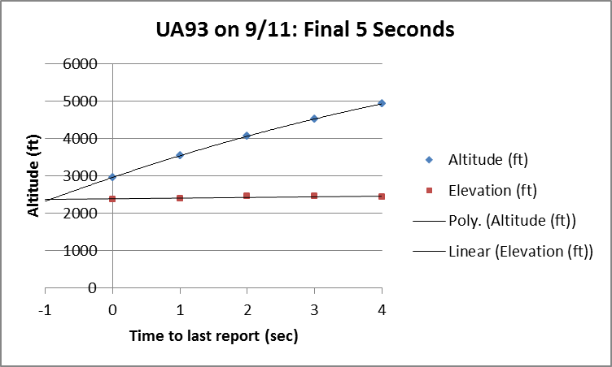
Fig. 4 FDR data from UA93, final 5 seconds.
It is important to note that, even if the plane was at the highest point possible when the last valid data point was recorded, 473 + 250 = 723 feet, it would be impossible for it to avoid crashing into the ground, given its very high speed and the steepness of its descent. Pulling out of this dive before ground level would produce a force of over 7g. This is 2.8 times larger than the legal maximum load, 2.5g, and about twice the force that could be survived. The force is even larger, over 8g, if the recorded pitch is assumed to be correct. The plane could only have continued in flight for a fraction of a second. Thus the proposition that the last 3 minutes of data on the FDR file was erased, and that the plane flew on for a further 3 minutes, cannot be correct if the FDR data is authentic to this point. Its authenticity is supported by both the radar data and infra-red data, as will be shown below.
Using the data and calculations provided here, the lowest estimate for the plane when recording finished is 473 – 250 = 223 feet. If we wish to be pedantic we can subtract a further trivial 17 feet to allow for the fact that the static ports, where the pressure altitude is sensed, would be that distance above the ground when the nose makes contact.
Although these calculations suggest that the plane was destroyed about 200 feet above the ground, there are assumptions involved which require caution. We do not have an error calibration for the radio height and have used a reported estimated value at the calculated distance above the ground at the time of the last recording. This could be substantially out. If the possible error is not 5%, as used above, but 9% the final reading would be at ground level. Also no allowance has been made for any difference between the barometric pressure at the last useful radio height and that at the impact zone. Clearly it would be foolish, given the uncertainties involved, to assert that the plane was destroyed above the ground on the basis of the FDR data alone. Additional evidence must be examined.
FDR Course Data
If the position data is plotted, the course of the plane can be examined. The following graph (Fig. 5) shows the last 7.5 minutes of flight. It is apparent when this period commences that the plane is controlled by the autopilot as the track is very straight. The magnetic heading is 122 degrees, which would take it a little to the left of the Capitol, suggested as a likely target for the hijackers.² At 5.6 minutes before the final report the plane commences a turn to the left. No explanation for this surprising change of course has ever been suggested. A new heading is established at about 85 degrees.
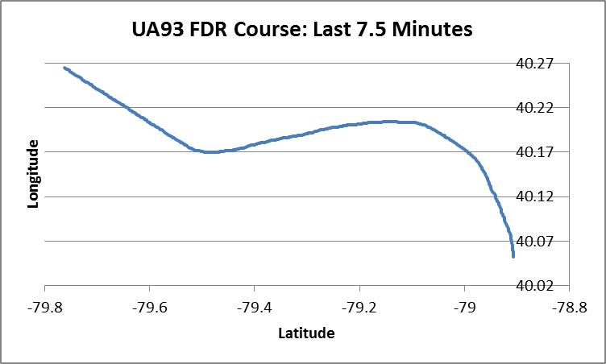
Fig. 5 The course of UA93 for the last 7.5 minutes of flight, from the FDR.
The track is no longer quite straight so it can be concluded that the autopilot has been turned off. The track is nevertheless straight enough to have the appearance of being purposeful, rather than a random act. The heading persists till about 3 minutes remain, whereupon a turn to the right commences. This turn is unusually slow and slightly irregular which suggests that, whatever the purpose of his previous course change, the pilot has ceased to be concerned about the direction of flight.
Pilot action
If control wheel angle, roll angle and altitude data from the FDR file are plotted over the same period, the behaviour of the hijackers can be studied (Fig. 6). At 5 minutes to the final record the pilot starts to swing the control wheel wildly. This corresponds with the official narrative in that this action would upset the passengers, whose efforts to break into the cockpit might now be sounding likely to succeed.
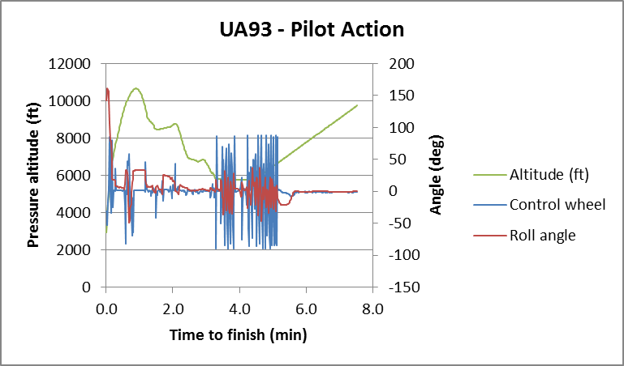
Fig. 6 Extreme pilot action in rocking the aircraft is seen for about 2 minutes.

Examination of the data shows that the pilot is not experienced in this aircraft. He is using extreme movements of the control wheel, often to the limit of rotation, but his timing is not appropriate for the inertia of this heavy aircraft. He reverses the wheel too soon, thus preventing the plane from achieving the possible severity of rolling action. After this period is over, the pilot is observed to fail to attend properly to altitude, just as he previously lost interest in his heading. One may suspect that it was at this time that the hijackers began to realize that they could not succeed with their aim, whatever that might have been. The Cockpit Voice Recorder (CVR) contains evidence that they discuss ending the flight. There are a few more weak actions to upset the passengers, mainly by sharply raising and lowering the nose of the aircraft (not shown on the graph), then the plane is dived toward the ground and rolled over, almost fully onto its back.
Careful study of the FDR data from both AA77 and UA93 shows that the planes, when not travelling on autopilot, were behaving erratically in ways indicating that they were under the control of inexperienced pilots. It would be extremely difficult to incorporate the myriad small oddities observed in the data. This finding does not prove that the final path of AA77 was under human control. Only a very brief utilization of external control, or control by an on-board device to lock out the pilot, would be required to ensure a successful outcome. Such a brief handover would be hard to detect. Similarly, in the case of UA93, despite the action of the plane shown in Fig. 6 being very strong evidence for human control, there is no proof that human control was maintained right to the end. It is conceivable that the CVR tape has been doctored to give the impression that the hijackers decided to crash the plane, while in fact control, in the end, was taken out of their hands.
Radar data
Radar data is available for most of the flight. It cannot be provided for the last few seconds as intervening high ground blocks transmission below about 6400 feet. The track (Fig. 7), however, clearly matches that from the FDR.

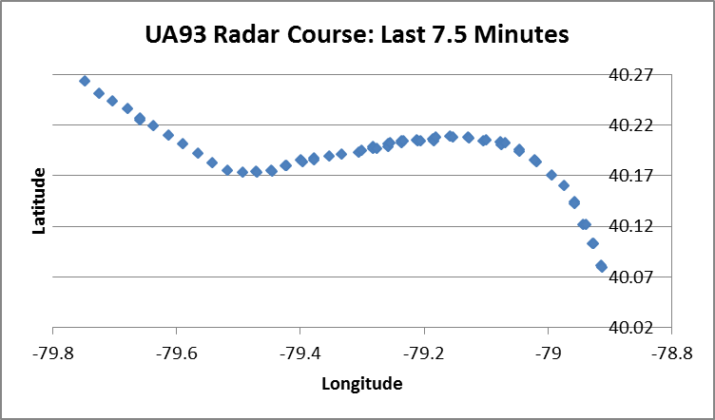

Fig. 7 Radar course
Careful study of this graph shows that the data set from which it was derived was a compilation from two or more radar stations. These are falling along virtually the same line, thus strengthening the support radar provides to the FDR data.
Impact time conclusion

The National Transport Safety Bureau (NTSB) went to some trouble to correct the event time data in their radar reports and they also correlated this data with the FDR data. They provided a detailed document showing how they combined information from many sources and we can be pretty sure they did this correctly to the last second. As already mentioned, the FDR data was three seconds out, as confirmed also by John Farmer. It is very hard for me to believe that the NTSB made an innocent mistake when they presented to the public their CSV version of the data file on the flight of AA77 with the time line adjusted by 4 seconds without comment. They surely knew that this adjustment created false information and would cause great confusion among truth activists regarding the Pentagon attack. Fortunately there is no such adjustment for us to contend with in the UA93 data.
The correspondence between the time-corrected radar and FDR data is so strong, and the mental picture the FDR creates of the plane rapidly descending, so steeply and so close to the ground, is so compelling, that it is very difficult to sustain the view that the flight terminated at any time other than the official time, 10:03:11, within a second or two. Certainly the claimed seismic time of 10:06 is ruled out.
It turns out that the month of October 2014 is important for the UA93 debate as Miles Kara at last received infra-red data he requested from the National Security Agency. This data provides virtually irrefutable confirmation that the official impact time is correct. The graph for UL93 shows that infra-red detection commenced at about 10:03:10.5. This time is indistinguishable within measurement error from the official impact time and the time derived from the FDR data.
Kara’s website also provides a useful discussion of the factors which show that the seismic data should be regarded as very weak evidence for impact at 10:06.
Witness testimony
Much has been made of the testimony of Susan McElwain who was very close to the crash site. She, herself, casts doubt on some of the remarks she has made in interviews by pointing out that she has been influenced by much forceful advice that what she saw was a missile. If we examine her first interview, however, there seems to be little doubt that what she saw, at very close quarters, was a small jet plane.
“To me it would be like ... a small Lear jet. It had the big fin on the back (she gestures upward) and goes across (she gestures horizontally)”.

Fig. 8 Learjet
In another interview she stated: "It had two rear engines, a big fin on the back like a spoiler on the back of a car and with two upright fins at the side”. The two upright fins would correspond with the winglets seen on Learjets. By combining these two statements we obtain a good description of the back end of a Learjet (Fig. 8).
As the plane flew low over her van she saw it bank to the right then disappear behind some trees. A few seconds later she heard a loud explosion and assumed the plane had crashed, but this was not the case. Two things follow from the statements by McElwain: firstly she was not observing the final seconds of the flight of UA93, as the plane she saw was too small, too low, flying horizontally and travelling in the wrong direction, and secondly, what she saw was not a missile: a missile looks quite different and could not be seen to bank to the right.
In the same report McElwain is quoted as making some remarkable claims. She reports that a friend phoned her to say that her husband had shot down UA93. This leads to an interesting thought. Due to the precision with which the other three planes hit their targets, many students of 9/11 assert that some form of remote control must have been utilized, at least in the final stages of the flights. As so much time had elapsed between the first hijacking and the establishment of UA93’s path toward the Capitol, it would have been absurd for the authorities to have allowed this plane, so obviously hijacked, to continue on its course. Could all four of these aircraft have been fitted with an explosive to destroy it if such an action became necessary? Could a fighter jet have been despatched to shoot down UA93 or to activate an on-board explosive? These are clearly tenable possibilities.
A difficulty with the shoot-down scenario lies in the behaviour of UA93. It suddenly dived and turned onto its back and was obviously on a lethal course. There would be no need to shoot it at this late stage. The only feasible theory is that the fighter jet came upon UA93 when it was still high above the ground and flying normally. If the jet shot it before the dive, it could have crippled the plane or the pilot, causing the dive to be initiated. In this case it would be likely that the attack would have been observed and reported by numerous witnesses, but no such reports have appeared.
Some of the early studies of the flight of UA93 have included the claim that debris falling around Indian Lake is proof that the plane was damaged in that vicinity. We know from the work of John Farmer, studying radar data, that a cloud of debris appeared in the vicinity of the crash site at the time of the crash. This cloud then proceeded to travel in the direction of Indian Lake at about 29 knots. As the objects that fell there appear to be all small and light, it is reasonable to believe that they would be capable of travelling a considerable distance, once lifted by the convection current of the large fireball produced by the burning fuel. There is therefore no proof from this observed debris that the plane was damaged anywhere other than at or near the impact site.
Many witnesses reported seeing the last stages of the flight of UA93. In general, these reports correspond well with the FDR data in that they report the plane climbing then very steeply diving and turning over. Few, perhaps none, were in a position to see the impact. Linda Shepley said the plane was intact when it plunged downward.
Seismic data
A substantial discussion occurred on the Randi website of the possibility that the seismic signal at 10:06 was caused by a sonic boom. The discussion was well referenced. Its eventual conclusion was that the signal, when analysed, did not look right for a sonic boom. This makes the sonic boom claim doubtful but it does not rule it out.
Impact site debris
In the case of the Pentagon attack, many claimed that it should have been possible to see recognizable wings or parts of wings at the crash site, but this view has been soundly refuted by study of the F4 Phantom experiment. This showed conclusively that high speed impact of a plane with a solid object produced total fine fragmentation. The crash of UA93 was at a similar speed, though not into such an unyielding object. We can therefore expect to find fragments of a range of sizes. The largest piece found so far among the various photos is a part of the fuselage encompassing two passenger windows (Fig. 9), presented at the Mousawi trial.
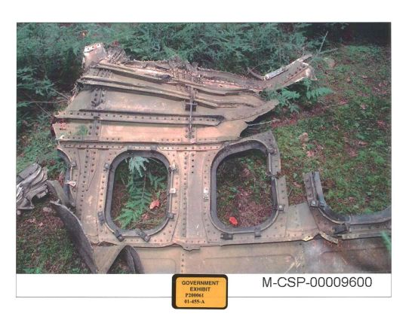
Fig. 9 Fragment of UA93.
A substantial number of small objects was also found. Very dense objects like an engine or a black box would be expected to penetrate soil if the angle of impact was sufficient. These objects were observed to penetrate the wall of the Pentagon and have been reported as found deep in the ground at the UA93 crash site. Here we see an engine being removed from the site (Fig. 10).
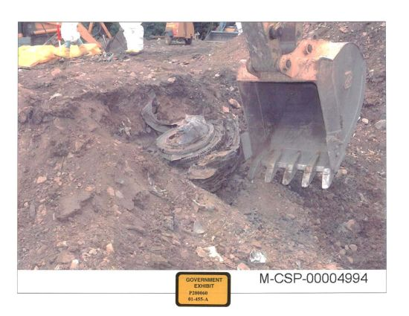
Fig. 9 Engine recovery from crater.
Engine separation
It has been reported by many witnesses that an engine, or part of an engine, was found some distance away from the crash site. We know which way the plane was travelling at the moment of impact, so we know the general direction the engine would have to travel after impact. One witness who seems reasonably reliable is Jeff Reinbold, the National Park Service representative responsible for the Flight 93 National Memorial. He states that the engine travelled south for 300 yards from the impact site. That seems a reasonable distance and is in the correct direction. It follows that the separate engine is not proof that the plane was destroyed before impact. For this we need reliable witnesses that the engine was too far away or in the wrong direction. Given that this is such a crucial aspect of this discussion, to be taken seriously any claim that the engine was found in an impossible location would require corroboration by multiple reliable witnesses. What we have instead is numerous witnesses all reporting different distances and directions.
There are some images which show an impact mark on the ground that is narrow, as would be made by an intact wing. This suggests that the plane was relatively intact at impact but does not prove that it had not been sufficiently damaged above the ground to release an engine.
There are reports that considerable damage was done to a house in the bush. This implies that a severe explosion occurred at or very close to the ground. This would tend to produce the reported scattering of debris. There is no evidence here that the plane was attacked by a missile as the explosion would have occurred regardless, due to the ignition of its fuel on impact.
Summary and conclusion
The suspicion remains plausible that UA93 was shot down by a nearby aircraft or damaged by an explosive device. There is no clear proof, however, that the official description, which has the plane brought down and deliberately crashed by the hijackers, is false.
The FDR evidence that places the termination of the flight substantially above ground is contradicted by the infra-red evidence which shows that the fireball was detectable a fraction of a second before the last FDR signal. They occurred at the same time, as near as could be measured. There is therefore no hard evidence proving that the plane was destroyed at an elevation other than ground level.
It appears highly unlikely that the seismic signal at 10:06 was caused by a sonic boom. This signal was also so weak that it is quite likely that it was nothing more than background noise.
The only clear conclusion that has emerged from the evidence so far is that the official impact time for UA93 is, with very high probability, correct.

The Pentagon attack: http://www.journalof911studies.com/resources/Legge-Letter-June.pdf
“We have some planes”, “We are sure that the nation owes a debt to the passengers of United 93.Their actions saved the lives of countless others, and may have saved either the Capitol or the White House from destruction.”: http://govinfo.library.unt.edu/911/report/911Report_Ch1.htm
Scholars for 9/11 Truth and Justice: http://stj911.org/evidence/flight93.html#timeline
John Farmer: http://bluecollarrepublican.files.wordpress.com/2011/02/radar-and-ntsb-time-normalization.pdf
Legge F and W Stutt: http://www.journalof911studies.com/volume/2010/Calibration%20of%20altimeter_92.pdf
Radio height error: http://www.naic.edu/~phil/rfi/NAR_Radio_Altimeter.pdf
Radar data provided by John Farmer, personal communication.
Recorded Radar Data Study: http://www.911myths.com/Recorded_Radar_Data_Study--all_four_aircraft.pdf
Kara, M: http://www.oredigger61.org/?p=6493
McElwain interview: http://www.youtube.com/watch?v=1QtzVC4uIS8
McElwain interview: http://web.archive.org/web/20030219235650/http:/www.mirror.co.uk/news/allnews/page.cfm?objectid=12192317&method=full
John Farmer, personal communication.
Shepley, L., and J. Reinbold: http://www.unexplained-mysteries.com/forum/index.php?showtopic=129555&st=15
http://forums.randi.org/archive/index.php/t-124901.html
F4 Phantom experiment: http://www.youtube.com/watch?v=AB4IEa7jTJw
Jeff Reinbold: http://www.popularmechanics.com/technology/military/news/debunking-911-myths-flight-93

